**Database Design:**

a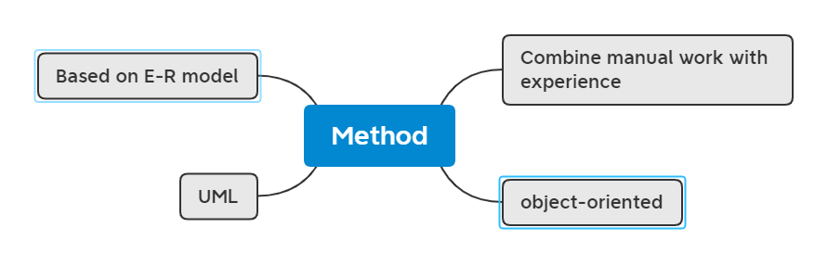

Database design

Feature

* Design
* Management
* Combine structural data design with behavioral data design
* The data base

Method

1. Combine manual work with experience

The database designed by this method often has poor performance and is prone to various problems

1. Based on E-R model

It mainly uses E-R diagram to describe the conceptual model of the real world

1. UML

UML is a standard for object management organizations. It is not specifically for data modeling but a normative language that provides modeling and visualization support for all stages of software development. It provides multi-type model description diagrams

4. Object-oriented

Step

1. Demand analysis
   * Method of requirements analysis

It is mainly to communicate with users

* + Requirements analysis tasks

Through the analysis of the objects to be processed to understand the working situation of the original database system, clear user needs and determine the functions of the new system

* + The data dictionary

1. The data items

2. Data structures

3. The data flow

4. Data storage

5. Process

2. Conceptual structure design

* + The conceptual model
  + E-R model
  + UML

3. Logical structure design

The basic E-R diagram designed by model concept is transformed into the data model supported by the database system

4. Operation and maintenance

Mainly operated by the database administrator

1. Dumps and maintenance

2. Control of completeness and completeness

3.Performance monitoring

4. Reorganization and reconstruction

5. Database implementation

* + Load the data
  + Application coding and debugging

6. Physical structure design

It is usually divided into two steps: determining the physical structure of the database and evaluating the physical structure

**ITPM**

* Project, project management, project stakeholder, project charter, risk, program.
* Internal rate of return, top ten risk item tracking, work breakdown structure.
* Kick-off meeting, net precent value, project scope, activity(task), project success.
* Free slack(free float), total slack(total float), direct costs, project quality, quality assurance.
* Pareto Chart, CMMI, responsibility assignment matrix(RAM), sensitivity analysis.
* Estimated monetart value(EMV), organizational breakdown structure(OBS).
* Maslow's Hierarchy of needs model, tuckman model, three-pointestimates, critical path method
* SWOT analysis, change control system, network diagrams, earned value management.
* Cause-and-effect diagrams, the seven run rule, pareto charts, delphi rechnique.
* Make-or-but analysis, the development trend of ITPM, schedule control suggestions.
* Top management commitment crucial for project managers, weighted scoring model.
* Calculation for NPV and ROI.
* Analyze project performance.
* Manage project change.
* Estimate project costs according to OBS and other information.
* Create the project WBS, speed up the project schedule.